Year 12 ATAR PHYSICS 2020
Practical Test ELECTROMAGNETISM TOTAL: /25

PART 1: Determining the field strength in a solenoid for an applied current.
Marks: /12

Name: ___________________________________________

Background:
When a current flows through a solenoid (a coil), a uniform magnetic field parallel to the sides of the solenoid is produced. The strength of the field (B) depends upon the current (I) applied.
Aim:
To apply a current in a solenoid and calculate the field strength produced inside the solenoid.
Equipment:
Current balance kit
Two ammeters (0-5A)
Two 12 V DC power pack
2 Rheostats
Connecting leads
Solenoid

Procedure:

- Set up the equipment as shown below. DO NOT TURN ON THE POWER.
- BALANCE THE LOOP so it is horizontal.
- When you have completed the circuit you raise your hand so that your teacher can check it.
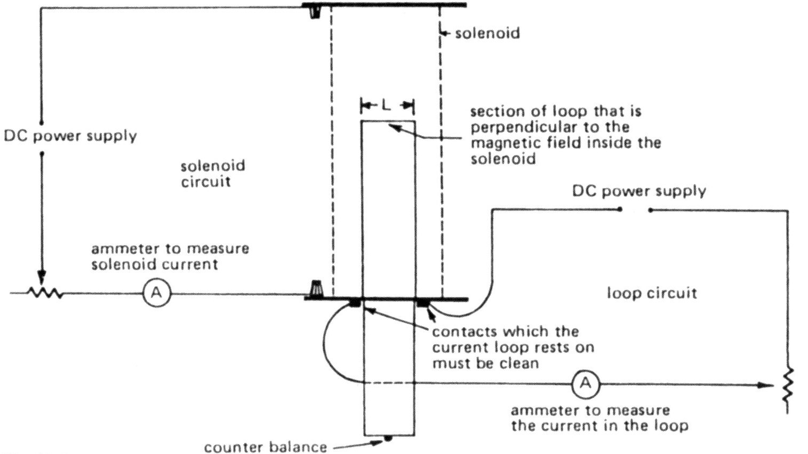
/3

/4

- Place a piece of the nichrome wire on the end of the loop.
/1

/4
Mass of 1.00m = 0.701g.

Mass of wire = __________g

- Switch on the circuit. Adjust the current in the solenoid and in the loop so that the loop is again horizontal.

Record results here: Solenoid current = _____________ Loop current = ______________
/2

/4
Raise your hand so that your teacher can check your readings

- Below is a diagram of the current balance setup:
SOLENOID

LOOP

F=
/1

/4
F=

Complete the formulae in the boxes.

- Using the correct current value, calculate the field strength in the solenoid.
/4

/4

ANSWER: A current of ______A in the solenoid produces a field strength of __________

/1

/4

END OF TEST

